# **Weekly Report – W19 Fall 2022**

## **Problem & Task**

1. Two weeks ago, the SRA model was modified with geometry factors of our project in TMTDyn package, the simulation ran successfully with a reasonable result, however, the animation seemed not good, in which adjacent links were separated too far away from each other when force exerting on the tip. So our job this week is to make some amendments according to the suggestions provided by Dr. Sadati last week to make it look normal (this process includes so many details which can be seen in the Solution section below).

Then we can expand this topic and make the package’s applicability more general, not just adaptable to our project, to be brief and simple, we can start from exploring the ratio of SRA’s length and radius/diameter leading to a reasonable simulation result.

1. Meanwhile I should not give up modelling the SRA simulation by our own, in the Solution section below I will update some details about each matrix in the equations of motion.

## **Solution**

1. *Refining the simulation results*

(1). Eliminating the physical experimental data

To achieve this target, I have tried different methods in the last two weeks, one was to check all the possible m files that include plot function, in my understanding it should locate in the files that would change with the model setting up, but after checking all the relatively “stable” m files, though there are some key words of “plot” (they could be plot3, plot or some other self-made functions), unfortunately they are not we looked for.

Thanks to Dr. Sadati’s suggestion, indeed by directly contacting the author of the package is always the most efficient way to solve problems, the target plot function is actually hidden in the path eom\post_proc.m. To make the readers easier to understand the results, except for erasing the confusing physical experimental data, I also made the size of the plot window more adaptable to the simulation time and meanwhile let the code automatically adjust the position of the legend to ensure the least conflict with the data in the plot box, also I added the title and unit for each axis according to the description in the author’s paper to decrease the confusion of the readers further more.

Based on the principle of once and for all, I have done the same thing for the input plot as well, to refine the code, I have to run the simulation again and again, during this period, the animation process can take a pretty long while, so I had to deactivate it temporarily, however, this goal cannot be realized simply by commenting corresponding lines of code, the function is invoked in the format of “ladder struct” structure as shown in the figure below, and the only way is to delete the whole sentence directly (I have taken notes about this operation at the bottom of the file) under the post_process() function.

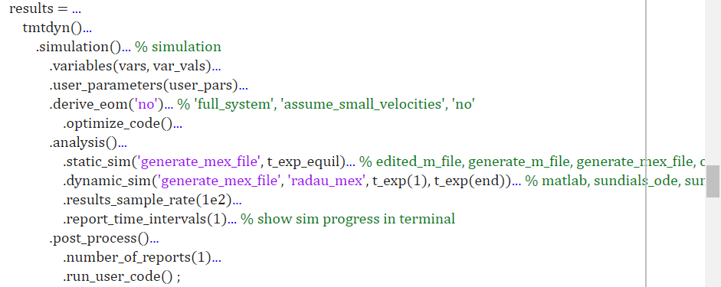

**Fig. W19-1** The screen shot of the “ladder struct” structure in the main function

To clarity my contributions via more apparent approach, the comparison of the before and after effects are shown as follows in terms of the input and simulation results.

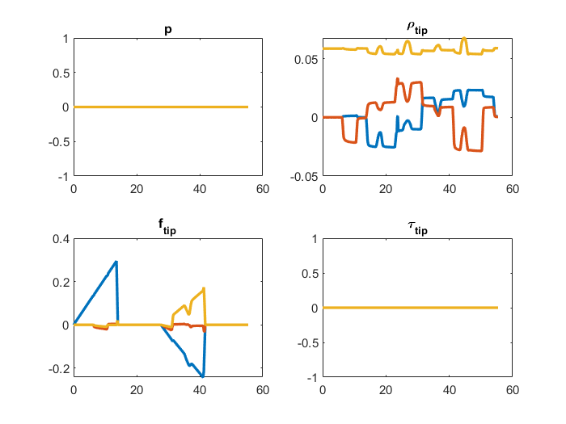

**Fig. W19-2** The example of input plot before modification

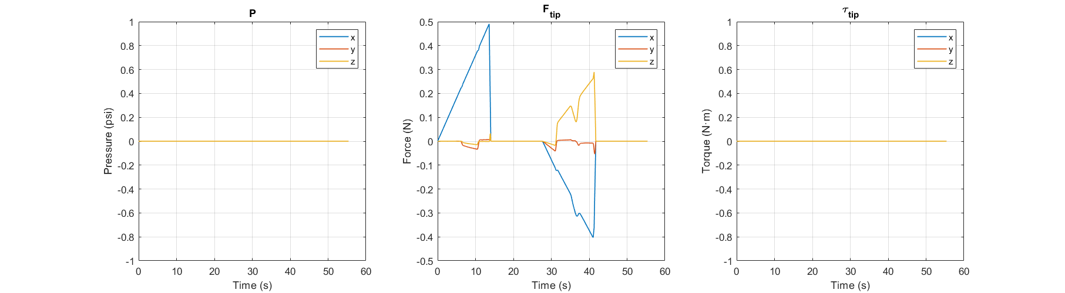

**Fig. W19-3** The example of input plot after modification

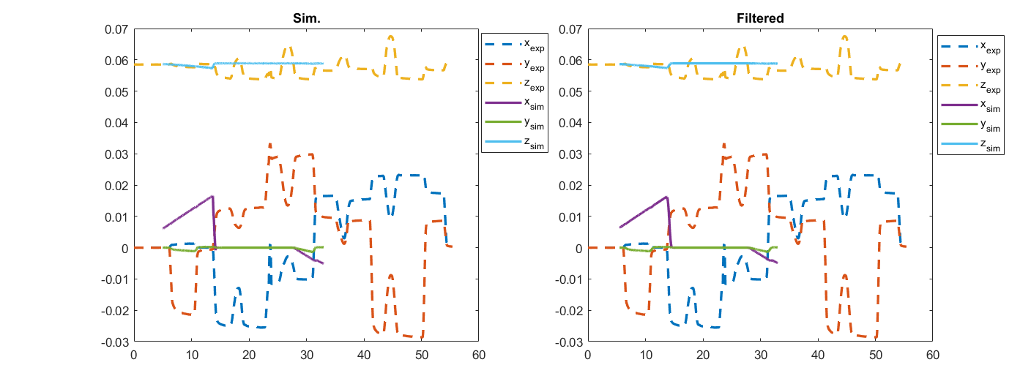

**Fig. W19-4** The example of simulation results (tip position) before modification

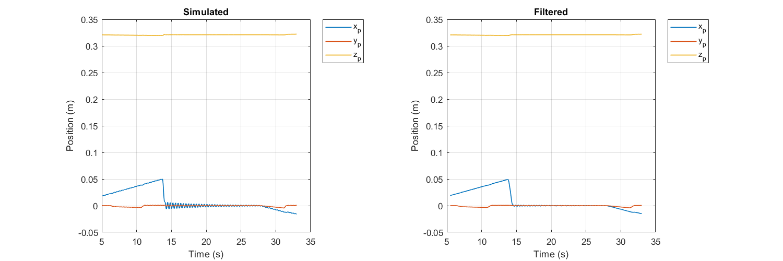

**Fig. W19-5** The example of simulation results (tip position) after modification

The example test was performed under the condition that the SRA was driven only under the force exerted on the x direction, from the first two figures (Fig. W19-2 and Fig. W19-3), we can clearly see that the unnecessary physical experimental data was excluded, and each type of input is marked with clear legend to help readers distinguish each of them; from the subsequent two figures, though from the final effect, the only obvious difference between the two is the missing experimental data, the default size of the plot box was high condensed and the default position of the legend was inside the box which had serious conflict issue with the data, every time we have to drag the window and the legend box to the state which is suitable for screen shot and data recording and it is inconvenient, this is the reason why I made such modifications.

(2). Fixing the “separated segment” animation

This specific topic is actually based on the second question I proposed in the email (which I also c.c. to you), Dr. Sadati and me talked quite a lot about the “failed simulation” (which should be defined as “fake simulation result” corrected by Dr. Sadati) especially for very “long” and “thin” SRA scenarios. Here I will combine both the topics (separated segment and fake simulation result due to extreme geometry settings) to discuss the possible reasons behind.

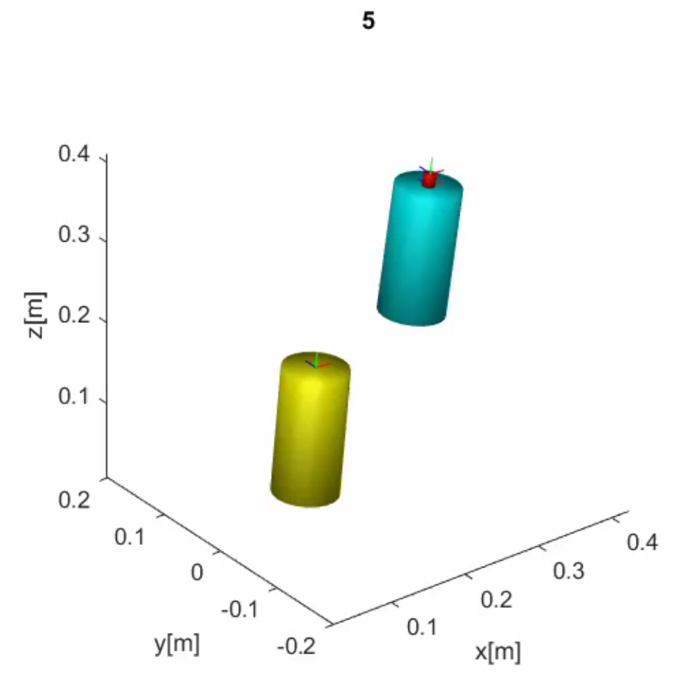

**Fig. W19-6** The screen shot of the fake animation of segment separated from each other

Above is an example of the fake simulation animation with the input of force exerted on the SRA tip in the x direction only, which was gradually increased to the maximum value 0.5 N, meanwhile without any pressure input, Dr. Sadati and me both laughed when we watched the video record, and he proposed the following several possible reasons:

* Separated segment was basically caused by too large shear force, we can try to check if the input force is too large (but it turned out not, the force exerted on the tip was only 0.5 N for the simulation);
* The material used in the author’s paper is different from our project, it is suggested to enlarge the density or the Young’s Modulus of the material to see if anything can be improved;
* The number of pneumatic chambers in the author’s paper is six while in our project there are only three, so if we still implement the same amount of pressure input and using the original model, the simulation might differ largely due to the accumulated effect of larger number of chambers, we can try to modified the property.

According to the instructions of Dr. Sadati, if we would like to decrease the number of chambers from six to three, we have to modified the rotation matrix which is 6 by 6 as follows,

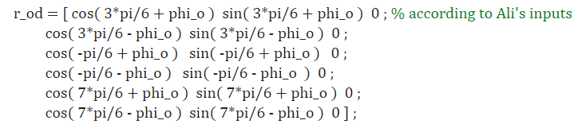

**Fig. W19-7** The rotation matrix to record the position of the center of each chamber (6 chambers’ model)

And we need to rewrite this matrix into the following one, the parameter phi_o is the offset angle, we don’t need it anymore,

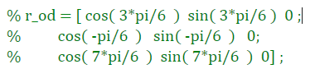

**Fig. W19-8** The modified rotation matrix to record the position of center of each chamber

And accordingly we should change the size of the pressure input from 6 to 3 as well, the path is eom\dym_mid_step.m, the modifications are shown as follows,

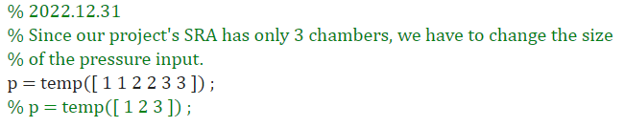

**Fig. W19-9** The modifications of pressure input

However, the package ran with errors, therefore there must be more places and functions we need to change in terms of the size, I will note it in my agenda next week.

On the other hand, I also did simulation with the Young’s Modulus changed only, the default value was set to be $E=120 GPa$, I multiplied this value by 1, 2, 3, 4, 5, 10 times respectively to see the results and animation, below is the comparison between 1 time and 4 times of the original Young’s Modulus at the same time instant (5 s), we can see that the influence of the Young’s Modulus is much larger than that of the density (the simulation we have done last week).

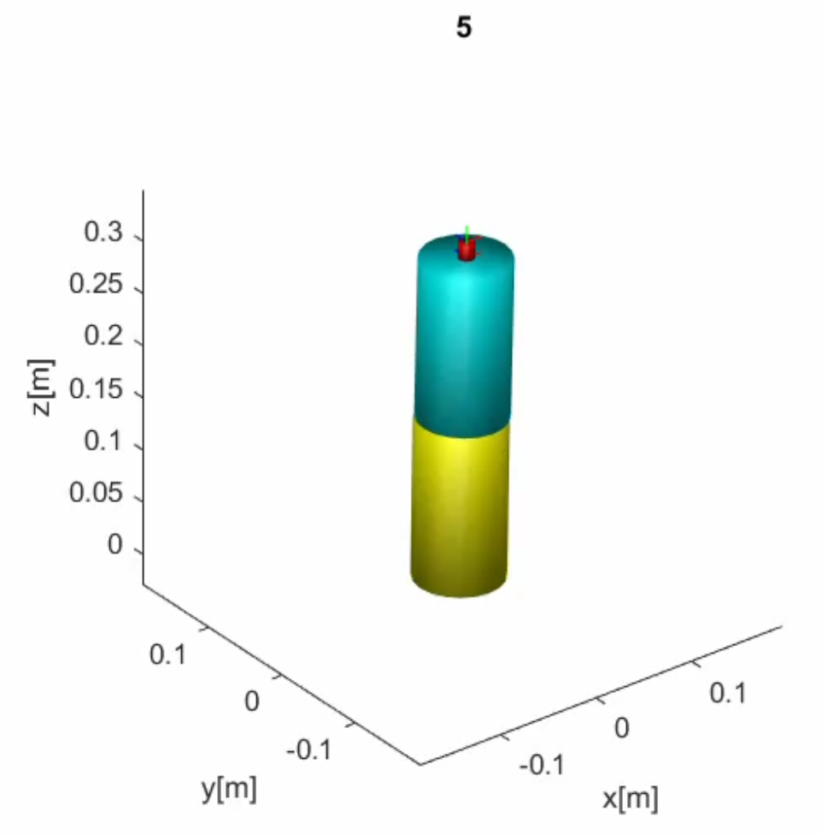

**(a)** **(b)**

**Fig. W19-10** The comparison of the animation effect between setting the Young’s Modulus value as 1 time and 4 times by the original value. (a) $1×$, (b) $4×$.

1. *Update about the self-made SRA simulation code*

The equations of motion can be separated by two parts, the left SRA and the right one, which can be simply summarized as follows,

$${\left[M_{L}\right]}_{2×2}\left[\begin{aligned}{\ddot{θ}}_{L1} \\ {\ddot{θ}}_{L2}\end{aligned}\right]+{\left[C_{L}\right]}_{2×2}\left[\begin{aligned}{\dot{θ}}_{L1} \\ {\dot{θ}}_{L2}\end{aligned}\right]+{\left[P_{gL}\right]}_{2×1}+{\left[P_{kL}\right]}_{2×1}+{\left[P_{cL}\right]}_{2×1}={\left[τ_{L}\right]}_{2×1}$$

$${\left[M_{R}\right]}_{2×2}\left[\begin{aligned}{\ddot{θ}}_{R1} \\ {\ddot{θ}}_{R2}\end{aligned}\right]+{\left[C_{R}\right]}_{2×2}\left[\begin{aligned}{\dot{θ}}_{R1} \\ {\dot{θ}}_{R2}\end{aligned}\right]+{\left[P_{gR}\right]}_{2×1}+{\left[P_{kR}\right]}_{2×1}+{\left[P_{cR}\right]}_{2×1}={\left[τ_{R}\right]}_{2×1}$$

where $M_{L}$ and $M_{R}$ are the inertia matrices for left and right SRAs respectively, $C_{L}$ and $C_{R}$ are Coriolis Centripetal matrices, and for the potential energy part, it can be divided into three parts due to the specification of this model, namely gravity ( $P_{gL}$ and $P_{gR}$), spring stiffness ( $P_{kL}$ and $P_{kR}$) and damping ( $P_{cL}$ and $P_{cR}$), their specific expressions can be seen below. From the coding experience of “falling SRA” project first version (using PCC theory), this version will be more mature, the code is still able to visualize the specific expression of each matrix for each time step, and simplify them as much as possible. However, Mathematica has a superiority over MATLAB in terms of symbolic variable calculation, so according to the complexity of each expression after the first processing of MATLAB, the complexity of inertia matrices is acceptable, the rest was simplified for the second time by Mathematica, for the brevity of the expressions, some of the parameters have been assigned with specific values at the start, which can be seen below.

**Table W19-1.** Parameters of SRA properties assigned

|  |  |
| --- | --- |
| **Parameter Name** | **Value with unit** |
| Length of each SRA $L$ | $$0.6 m$$ |
| Mass of each SRA $m$ | $$2.5 kg$$ |
| Distance between two walls $d$ | $$1 m$$ |
| Gravity acceleration $g$ | $$9.81 m/{s^{2}}$$ |
| Stiffness of spring between the COMs of two adjacent links $k$ | $$2 N/m$$ |
| Damping coefficient of the damper between the COMs of two adjacent links $c$ | $$1 {\left(N∙s\right)}/m$$ |

(1). Inertia matrix (M)

$$M_{L}=\left[\begin{matrix}\frac{27}{80}\cos{θ_{L2}}-\frac{14427}{12800}\sin\left(θ_{L1}+θ_{L2}\right)-\frac{12027}{12800}\sin{θ_{L1}}+\frac{2513}{1280} & \frac{27}{160}\cos{θ_{L2}}-\frac{9}{16}\sin\left(θ_{L1}+θ_{L2}\right)+\frac{81}{320} \\ \frac{27}{160}\cos{θ_{L2}}-\frac{29043}{51200}\sin\left(θ_{L1}+θ_{L2}\right)-\frac{81}{25600}\sin{θ_{L1}}+\frac{135}{512} & \frac{81}{1280}\sin^{2}\left(θ_{L1}+θ_{L2}\right)-\frac{27}{12800}\sin\left(θ_{L1}+θ_{L2}\right)+\frac{81}{320}\end{matrix}\right]$$

Each element in the matrix is so complex, thus for the following matrices, we are going to pick them out individually as follows.

$$M_{L}\left(1, 1\right)=\frac{27}{80}\cos{θ_{L2}}-\frac{14427}{12800}\sin\left(θ_{L1}+θ_{L2}\right)-\frac{12027}{12800}\sin{θ_{L1}}+\frac{2513}{1280}$$

$$M_{L}\left(1, 2\right)=\frac{27}{160}\cos{θ_{L2}}-\frac{9}{16}\sin\left(θ_{L1}+θ_{L2}\right)+\frac{81}{320}$$

$$M_{L}\left(2, 1\right)=\frac{27}{160}\cos{θ_{L2}}-\frac{29043}{51200}\sin\left(θ_{L1}+θ_{L2}\right)-\frac{81}{25600}\sin{θ_{L1}}+\frac{135}{512}$$

$$M_{L}\left(2, 2\right)=\frac{81}{1280}\sin^{2}\left(θ_{L1}+θ_{L2}\right)-\frac{27}{12800}\sin\left(θ_{L1}+θ_{L2}\right)+\frac{81}{320}$$

For the right arm, we have

$$M_{R}=\left[\begin{matrix}M_{R11} & M_{R12} \\ M_{R21} & M_{R22}\end{matrix}\right]$$

$$\left\{\begin{aligned}M_{R11}=\frac{27}{80}\cos{θ_{R2}}-\frac{15\sqrt{5}}{32}\cos\left(θ_{R1}-\tan^{-1}{2}\right)-\frac{9\sqrt{5}}{16}\cos\left(θ_{R1}+θ_{R2}-\tan^{-1}{2}\right)+\frac{751}{320} \\ M_{R12}=\frac{9}{20}\cos\left(θ_{R1}+θ_{R2}\right)\left[\frac{9}{16}\cos\left(θ_{R1}+θ_{R2}\right)+\frac{3}{8}\cos{θ_{R1}}-\frac{5}{8}\right]-\frac{9}{20}\sin\left(θ_{R1}+θ_{R2}\right)\left[\frac{9}{16}\sin\left(θ_{R1}+θ_{R2}\right)-\frac{3}{8}\sin{θ_{R1}}-\frac{5}{4}\right] \\ M_{R21}=\frac{9}{16}\cos\left(θ_{R1}+θ_{R2}\right)\left[\frac{9}{20}\cos\left(θ_{R1}+θ_{R2}\right)+\frac{3}{10}\cos{θ_{R1}}-\frac{1}{2}\right]-\frac{9}{16}\sin\left(θ_{R1}+θ_{R2}\right)\left[\frac{9}{20}\sin\left(θ_{R1}+θ_{R2}\right)+\frac{3}{10}\sin{θ_{R1}}-1\right] \\ M_{R22}=\frac{81}{320}\end{aligned}\right.$$

(2). Coriolis-centripetal matrix (C)

$$C_{L}=\left[\begin{matrix}C_{L11} & C_{L12} \\ C_{L21} & C_{L22}\end{matrix}\right] C_{R}=\left[\begin{matrix}C_{R11} & C_{R12} \\ C_{R21} & C_{R22}\end{matrix}\right]$$

where each element in the matrix is shown as follows,

$$C_{L11}=-\left[\frac{12027}{25600}\cos{θ_{L1}}+\frac{14427}{25600}\cos\left(θ_{L1}+θ_{L2}\right)\right]{\dot{θ}}_{L1}-\left[\frac{81}{51200}\cos{θ_{L1}}+\frac{11493}{20480}\cos\left(θ_{L1}+θ_{L2}\right)+\frac{27}{160}\sin{θ_{L2}}\right]{\dot{θ}}_{L2}$$

$$C_{L12}=\frac{3}{102400}\left\{2\left(8018{\dot{θ}}_{L1}-27{\dot{θ}}_{L2}\right)\cos{θ_{L1}}+3\left(12824{\dot{θ}}_{L1}+12773{\dot{θ}}_{L2}\right)\cos\left(θ_{L1}+θ_{L2}\right)+5760({\dot{θ}}_{L1}+2{\dot{θ}}_{L2})\sin{θ_{L2}}+1080{\dot{θ}}_{L2}\sin\left[2\left(θ_{L1}+θ_{L2}\right)\right]\right\}$$

$$C_{L21}=-\frac{3}{102400}\left[(2(8072{\dot{θ}}_{L1}-27{\dot{θ}}_{L2})\cos{θ_{L1}}+(38598{\dot{θ}}_{L1}+38355{\dot{θ}}_{L2})\cos\left(θ_{L1}+θ_{L2}\right)+11520{\dot{θ}}_{L2}\sin{θ_{L2}})\right]$$

$$C_{L22}=\frac{3}{102400}\left((-16144{\dot{θ}}_{L1}+54{\dot{θ}}_{L2})\cos{θ_{L1}}-3(12905{\dot{θ}}_{L1}+12797{\dot{θ}}_{L2})\cos\left(θ_{L1}+θ_{L2}\right)+360\left\{-32{\dot{θ}}_{L2}\sin{θ_{L2}}+3({\dot{θ}}_{L1}+{\dot{θ}}_{L2})\sin\left[2\left(θ_{L1}+θ_{L2}\right)\right]\right\}\right)$$

$$C_{R11}=\frac{1}{320}\left[-150{\dot{θ}}_{R1}\cos{θ_{R1}}-180({\dot{θ}}_{R1}+{\dot{θ}}_{R2})\cos\left(θ_{R1}+θ_{R2}\right)+75{\dot{θ}}_{R1}\sin{θ_{R1}}-54{\dot{θ}}_{R2}\sin{θ_{R2}}+90({\dot{θ}}_{R1}+{\dot{θ}}_{R2})\sin\left(θ_{R1}+θ_{R2}\right)\right]$$

$$C_{R12}=-\frac{3}{320}\left[50{\dot{θ}}_{R1}\cos{θ_{R1}}+60(2{\dot{θ}}_{R1}+{\dot{θ}}_{R2})\cos\left(θ_{R1}+θ_{R2}\right)-25{\dot{θ}}_{R1}\sin{θ_{R1}}+18{\dot{θ}}_{R1}\sin{θ_{R2}}+18{\dot{θ}}_{R2}\sin{θ_{R2}}-60{\dot{θ}}_{R1}\sin\left(θ_{R1}+θ_{R2}\right)-30{\dot{θ}}_{R2}\sin\left(θ_{R1}+θ_{R2}\right)+27{\dot{θ}}_{R2}\sin\left(θ_{L1}+θ_{L2}+θ_{R1}+θ_{R2}\right)\right]$$

$$C_{R21}=\frac{1}{320}\left\{-3\left[50{\dot{θ}}_{R1}\cos{θ_{R1}}+60({\dot{θ}}_{R1}+{\dot{θ}}_{R2})\cos\left(θ_{R1}+θ_{R2}\right)-25{\dot{θ}}_{R1}\sin{θ_{R1}}+18{\dot{θ}}_{R1}\sin\left(θ_{L1}+θ_{L2}+θ_{R1}\right)+18{\dot{θ}}_{R2}\sin{θ_{R2}}\right]+90({\dot{θ}}_{R1}+{\dot{θ}}_{R2})\sin\left(θ_{R1}+θ_{R2}\right)-81({\dot{θ}}_{R1}+{\dot{θ}}_{R2})\sin\left(θ_{L1}+θ_{L2}+θ_{R1}+θ_{R2}\right)\right\}$$

$$C_{R22}=\frac{1}{320}\left\{-3\left[50{\dot{θ}}_{R1}\cos{θ_{R1}}+60({\dot{θ}}_{R1}+{\dot{θ}}_{R2})\cos\left(θ_{R1}+θ_{R2}\right)-25{\dot{θ}}_{R1}\sin{θ_{R1}}+18{\dot{θ}}_{R1}\sin\left(θ_{L1}+θ_{L2}+θ_{R1}\right)+18{\dot{θ}}_{R2}\sin{θ_{R2}}\right]+90({\dot{θ}}_{R1}+{\dot{θ}}_{R2})\sin\left(θ_{R1}+θ_{R2}\right)-81({\dot{θ}}_{R1}+{\dot{θ}}_{R2})\sin\left(θ_{L1}+θ_{L2}+θ_{R1}+θ_{R2}\right)\right\}$$

(3). Potential energy due to gravity

$$P_{gL}=\left[\begin{aligned}-\frac{8829}{1600}\left[\cos\left(θ_{L1}+θ_{L2}\right)+\cos{θ_{L1}}\right] \\ -\frac{8829}{1600}\cos\left(θ_{L1}+θ_{L2}\right)\end{aligned}\right]$$

$$P_{gR}=\left[\begin{aligned}-\frac{8829}{1600}\left[\cos\left(θ_{R1}+θ_{R2}\right)+\cos{θ_{R1}}\right] \\ -\frac{8829}{1600}\cos\left(θ_{R1}+θ_{R2}\right)\end{aligned}\right]$$

(4). Potential energy due to “spring” stiffness

$$P_{kL}=\left[\begin{aligned}\frac{3\left[\cos{θ_{L1}}+3\cos\left(θ_{L1}+θ_{L2}\right)\right]\left[6\sqrt{2}-\sqrt{95+27\cos{θ_{L2}}-30\sin{θ_{L1}}-90\sin\left(θ_{L1}+θ_{L2}\right)}\right]}{20\sqrt{95+27\cos{θ_{L2}}-30\sin{θ_{L1}}-90\sin\left(θ_{L1}+θ_{L2}\right)}} \\ \frac{9\left[10\cos\left(θ_{L1}+θ_{L2}\right)+3\sin{θ_{L2}}\right]\left[6\sqrt{2}-\sqrt{95+27\cos{θ_{L2}}-30\sin{θ_{L1}}-90\sin\left(θ_{L1}+θ_{L2}\right)}\right]}{200\sqrt{95+27\cos{θ_{L2}}-30\sin{θ_{L1}}-90\sin\left(θ_{L1}+θ_{L2}\right)}}\end{aligned}\right]$$

$$P_{kR}=\left[\begin{aligned}\frac{3\left[\cos\left(θ_{R1}+\cot^{-1}{2}\right)+3\cos\left(θ_{R1}+θ_{R2}+\cot^{-1}{2}\right)\right]\left\{-12+\sqrt{{\left[-5+3\cos{θ_{R1}}+9\cos\left(θ_{R1}+θ_{R2}\right)\right]}^{2}+{\left[-10+3\sin{θ_{R1}}+9\sin\left(θ_{R1}+θ_{R2}\right)\right]}^{2}}\right\}}{8\sqrt{5}\sqrt{{\left[-5+3\cos{θ_{R1}}+9\cos\left(θ_{R1}+θ_{R2}\right)\right]}^{2}+{\left[-10+3\sin{θ_{R1}}+9\sin\left(θ_{R1}+θ_{R2}\right)\right]}^{2}}} \\ -\frac{9\left[5\sqrt{5}\cos\left(θ_{R1}+θ_{R2}+\cot^{-1}{2}\right)+3\sin{θ_{R2}}\right]\left\{-12+\sqrt{{\left[-5+3\cos{θ_{R1}}+9\cos\left(θ_{R1}+θ_{R2}\right)\right]}^{2}+{\left[-10+3\sin{θ_{R1}}+9\sin\left(θ_{R1}+θ_{R2}\right)\right]}^{2}}\right\}}{200\sqrt{{\left[-5+3\cos{θ_{R1}}+9\cos\left(θ_{R1}+θ_{R2}\right)\right]}^{2}+{\left[-10+3\sin{θ_{R1}}+9\sin\left(θ_{R1}+θ_{R2}\right)\right]}^{2}}}\end{aligned}\right]$$

(5). Potential energy due to damping

$$P_{cL}=P_{cR}=\left[\begin{aligned}\frac{9}{400}\left[10{\dot{θ}}_{L1}+9{\dot{θ}}_{L2}+3(2{\dot{θ}}_{L1}+{\dot{θ}}_{L2})\cos{θ_{L2}}\right] \\ \frac{27}{400}\left[3({\dot{θ}}_{L1}+{\dot{θ}}_{L2})+{\dot{θ}}_{L1}\cos{θ_{L2}}\right]\end{aligned}\right]$$

(6). External force exerted on the end effector of each SRA

Temporarily I was stuck by this section, we know that the force exerted on the tip of the SRA (no matter for left or right) is composed of the gravity of the ball and the tension or traction force from the other arm, I’m a little confused about how to deal with the latter one. Maybe next week I can ignore it and try to do simulation with gravity only to see if the basic principle is correct.

## **Difficulty**

1. The simulation ran with errors when we changed the number of chambers from six to three according to the instructions by the author, clearly there are much more details and functions needed to be fixed, it would take a long time to make everything correct, so I reckon that we could decrease the pressure input by half to achieve the same effect;
2. For our project, the force exerted on the end effector of each SRA is partially from the other SRA, which means that the force is mutual, but it is hard to identified, maybe I should do more follow up study in the coming week.

## **Plan**

1. Do more simulation tests to find what is the proper ratio of SRA’s diameter and length that can lead to a reasonable simulation result (including the animation) for more general use of the package;
2. Seek a method to compute the force exerted on the tip of the SRA for our project.